**ENG TECH 3PR3**

Procedural and Object-Oriented Programming Concepts



Assignment 4

Submitted by: Qin Yang 400420584

Date: Feb 24th , 2022

**Part. A Modelling Login Attempts**

1. **Code**

import math

import matplotlib

matplotlib.use('TkAgg')

import matplotlib.pyplot as plt

import numpy as np

def get_inputs(): # getting file and insert value to an array

file01 = open("/Users/qinyang/Desktop/A04_sfwr_data_01.txt", "r")

s_file = []

s_file.extend(file01.readlines())

s_file = map(float, s_file)

return s_file

def setparameters(): # set up parameters

for a in np.arange(0, 2.01):

a = format(a, ".2f")

for b in np.arange(0, 2.01):

b = format(b, ".2f")

for mu in np.arange(0, 2.01):

mu = format(mu, ".2f")

return mu, a, b

def getfit(): # conduct brute force search to minimize mse to less than 1.0

t_total = 120

mse_trend = []

mse_better = 1000

s_file = get_inputs()

i = 0 # define how many iterations we compared mse

for a in np.arange(0, 2.01, 0.05):

for b in np.arange(0, 2.01, 0.05):

for mu in np.arange(0, 2.01, 0.05):

if mse_better < 1:

break

else:

mse_result = evaluatemode(a, b, mu, t_total, s_file)

if mse_result < mse_better:

i = i + 1

mse_better = mse_result

parameters_mse_min = [a, b, mu]

mse_trend.append(mse_better)

return mse_better, parameters_mse_min, i, mse_trend

def evaluatemode(a, b, mu, t_total, s_file): # calculate mse

n = t_total

s_calculated = []

for t in range(1, 121):

s = (-1) * (a * math.sin(2 * math.pi * t / t_total) + mu) * math.e ** (b * 2 * math.pi * t / t_total)

s_calculated.append(s)

s_subtract = np.subtract(s_calculated, s_file)

s_square = np.square(s_subtract)

s_sum = np.sum(s_square)

mse = s_sum / n

return mse

s_file = get_inputs()

setparameters()

mse_better, parameters_mse_min, i, mse_trend = getfit()

s_calculated = []

a = parameters_mse_min[0]

b = parameters_mse_min[1]

mu = parameters_mse_min[2]

T = 120

for t in range(1, 121):

s = (-1) * (a * math.sin(2 * math.pi * t / T) + mu) * math.e ** (b * 2 * math.pi * t / T)

print(s)

s_calculated.append(s)

print('The Value of A is: ', parameters_mse_min[0])

print('The Value of B is: ', parameters_mse_min[1])

print('The Value of mu is: ', parameters_mse_min[2])

print('The MSE predicted by pur model is: ', format(mse_better, ".3f"))

t_x = np.arange(1, 121, 1)

plt.scatter(t_x, s_file)

plt.plot(t_x, s_calculated)

plt.xlabel('Time [s]')

plt.ylabel('No.of attempts')

plt.show()

i_x = np.arange(0, i, 1)

plt.plot(i_x, mse_trend)

plt.xlabel('iterations')

plt.ylabel('MSE')

plt.show()

1. **Test Result**
2. Screenshot of print output

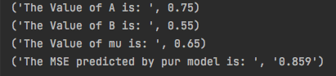

1. Screenshot of plot output

No. Attempts

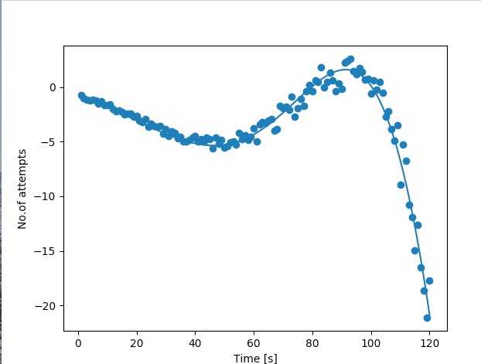

MSE Trend:

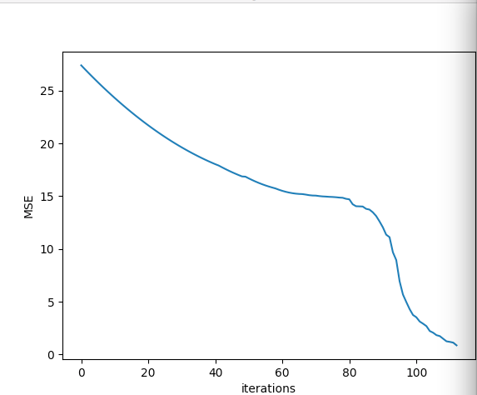

**Part. B Some Variation is observed**

1. **Code**

import math

import matplotlib

matplotlib.use('TkAgg')

import matplotlib.pyplot as plt

import numpy as np

def get_inputs(): # getting file and insert value to an array

file01 = open("/Users/qinyang/Desktop/A04_sfwr_data_03.txt", "r")

s_file = []

s_file.extend(file01.readlines())

s_file = map(float, s_file)

return s_file

def setparameters(): # set up parameters

for a in np.arange(0, 2.01):

a = format(a, ".2f")

for b in np.arange(0, 2.01):

b = format(b, ".2f")

for c in np.arange(0.01, 2.01):

c = format(c, ".2f")

for mu in np.arange(0, 2.01):

mu = format(mu, ".2f")

return mu, a, b, c

def getfit(): # conduct brute force search to minimize mse to less than 1.0

t_total = 120

mse_trend = []

mse_better = 1000

s_file = get_inputs()

i = 0 # define how many iterations we compared mse

for a in np.arange(0, 2.01, 0.05):

for b in np.arange(0, 2.01, 0.05):

for mu in np.arange(0, 2.01, 0.05):

for c in np.arange(0.05, 2.01, 0.05):

if mse_better < 0.5:

break

else:

mse_result = evaluatemode(a, b, c, mu, t_total, s_file)

if mse_result < mse_better:

i = i + 1

mse_better = mse_result

parameters_mse_min = [a, b, c, mu]

mse_trend.append(mse_better)

return mse_better, parameters_mse_min, i, mse_trend

def evaluatemode(a, b, c, mu, t_total, s_file): # calculate mse

n = t_total

s_calculated = []

for t in range(1, 121):

s = (-1) * (a * math.sin(2 * math.pi * t / t_total) + mu) * math.e ** (b * 2 * math.pi * t / (t_total * c))

s_calculated.append(s)

s_subtract = np.subtract(s_calculated, s_file)

s_square = np.square(s_subtract)

s_sum = np.sum(s_square)

mse = s_sum / n

return mse

s_file = get_inputs()

setparameters()

mse_better, parameters_mse_min, i, mse_trend = getfit()

s_calculated = []

a = parameters_mse_min[0]

b = parameters_mse_min[1]

c = parameters_mse_min[2]

mu = parameters_mse_min[3]

T = 120

for t in range(1, 121):

s = (-1) * (a * math.sin(2 * math.pi * t / T) + mu) * math.e ** (b * 2 * math.pi * t / T)

s_calculated.append(s)

print('The Value of A is: ', format(parameters_mse_min[0], ".3f"))

print('The Value of B is: ', format(parameters_mse_min[1], ".3f"))

print('The Value of C is: ', format(parameters_mse_min[2], ".3f"))

print('The Value of mu is: ', format(parameters_mse_min[3], ".3f"))

print('The MSE predicted by pur model is: ', format(mse_better, ".3f"))

t_x = np.arange(1, 121, 1)

plt.scatter(t_x, s_file)

plt.plot(t_x, s_calculated)

plt.xlabel('Time [s]')

plt.ylabel('No.of attempts')

plt.show()

i_x = np.arange(0, i, 1)

plt.plot(i_x, mse_trend)

plt.xlabel('iterations')

plt.ylabel('MSE')

plt.show()

1. **Test Result**
2. Screenshot of print output

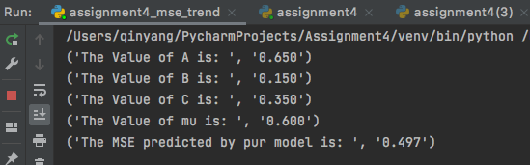

1. Screenshot of plot output

No. Attempts

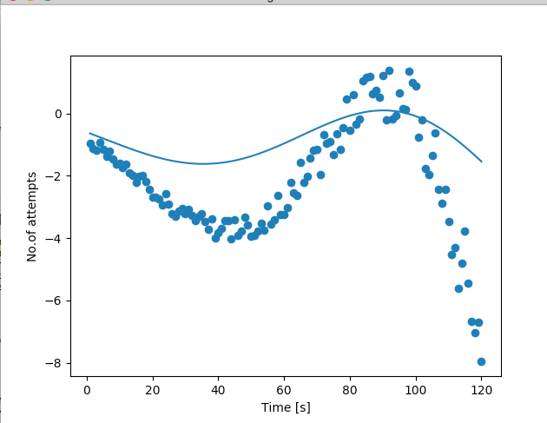

MSE Trend:

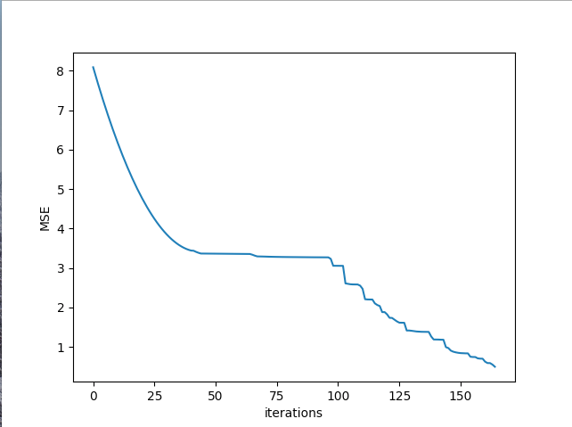

**Part. C Towards a generic model**

1. **Code**

import math

import matplotlib

matplotlib.use('TkAgg')

import matplotlib.pyplot as plt

import numpy as np

def get_inputs(): # getting file and insert value to an array

file01 = open("/Users/qinyang/Desktop/A04_sfwr_data_05.txt", "r")

s_file = []

s_file.extend(file01.readlines())

s_file = map(float, s_file)

return s_file

def setparameters(): # set up parameters

for a in np.arange(0, 2.01):

a = format(a, ".2f")

for b in np.arange(0, 2.01):

b = format(b, ".2f")

for c in np.arange(0.01, 2.01):

c = format(c, ".2f")

for mu in np.arange(0, 2.01):

mu = format(mu, ".2f")

for shift in np.arange(0, 1.51):

shift = format(shift, ".2f")

return mu, a, b, c, shift

def getfit(): # conduct brute force search to minimize mse to less than 1.0

t_total = 120

mse_trend = []

mse_better = 1000

s_file = get_inputs()

i = 0 # define how many iterations we compared mse

for a in np.arange(0, 2.01, 0.05):

for b in np.arange(0, 2.01, 0.05):

for mu in np.arange(0, 2.01, 0.05):

for c in np.arange(0.05, 2.01, 0.05):

for shift in np.arange(0.05, 1.51, 0.05):

print(a, b, c, mu, mse_better)

if mse_better < 0.1:

break

else:

mse_result = evaluatemode(a, b, c, mu, t_total, s_file, shift)

if mse_result < mse_better:

i = i + 1

mse_better = mse_result

parameters_mse_min = [a, b, c, mu, shift]

mse_trend.append(mse_better)

return mse_better, parameters_mse_min, i, mse_trend

def evaluatemode(a, b, c, mu, t_total, s_file, shift): # calculate mse

n = t_total

s_calculated = []

for t in range(1, 121):

s1 = (-1) * ((a * math.sin(2 * math.pi * t + shift) / t_total) + mu)

s2 = math.e ** (b * ((2 * math.pi * t / t_total) + shift / c))

s = s1 * s2

s_calculated.append(s)

s_subtract = np.subtract(s_calculated, s_file)

s_square = np.square(s_subtract)

s_sum = np.sum(s_square)

mse = s_sum / n

return mse

s_file = get_inputs()

setparameters()

mse_better, parameters_mse_min, i, mse_trend = getfit()

s_calculated = []

a = parameters_mse_min[0]

b = parameters_mse_min[1]

c = parameters_mse_min[2]

mu = parameters_mse_min[3]

shift = parameters_mse_min[4]

T = 120

for t in range(1, 121):

s1 = (-1) * ((a * math.sin(2 * math.pi * t + shift) / T ) + mu)

s2 = math.e ** (b * ((2 * math.pi * t / T) + shift / c))

s = s1 * s2

s_calculated.append(s)

print('The Value of A is: ', format(parameters_mse_min[0], ".3f"))

print('The Value of B is: ', format(parameters_mse_min[1], ".3f"))

print('The Value of C is: ', format(parameters_mse_min[2], ".3f"))

print('The Value of mu is: ', format(parameters_mse_min[3], ".3f"))

print('The Value of shift is: ', parameters_mse_min[4])

print('The MSE predicted by pur model is: ', format(mse_better, ".3f"))

t_x = np.arange(1, 121, 1)

plt.scatter(t_x, s_file)

plt.plot(t_x, s_calculated)

plt.xlabel('Time [s]')

plt.ylabel('No.of attempts')

plt.show()

i_x = np.arange(0, i, 1)

plt.plot(i_x, mse_trend)

plt.xlabel('iterations')

plt.ylabel('MSE')

plt.show()

1. **Test Result**
2. Screenshot of print output

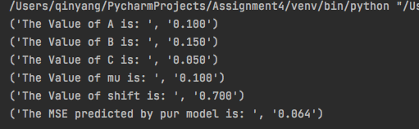

1. Screenshot of plot output

No Attempts:

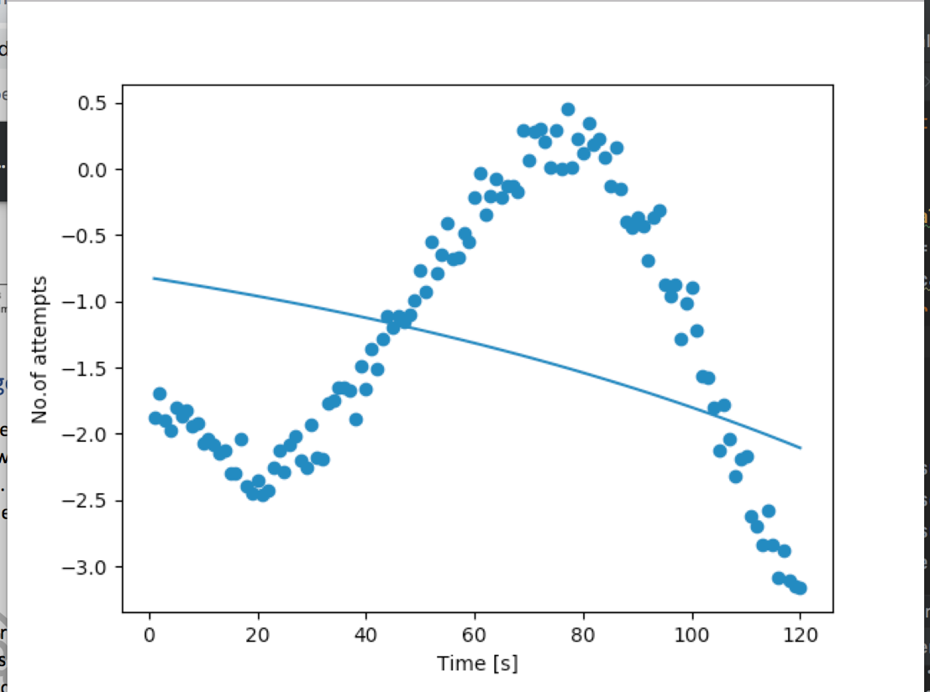

MSE:

